CREATE A KHANACADEMY USER ID
- Step 1: Go to the Khan Academy website: www.khanacademy.org
- Step 2: If you have an account already, click on Login in the upper right hand corner of the screen. If you do not have an account click on "Start Learning Now." There are a few ways to create an account. Pick the one that fits you best (email, Google, Facebook etc)

CHANGE YOUR USERNAME AND ASSIGN ME AS YOUR COACH
Once you've logged in and created your account:
- Step 3: Visit your Profile by clicking on your name (upper right hand corner.).
- Step 4: Change your profile name to something I would recognize. I can't give you credit if I can't find your work. First name and last initial works best in helping me locate your work.
- Step 5: On the very top menu you will see an item for COACHES. Click on COACHES.
- Step 6: In the box titled Add A Coach, enter my school email address: jfeller@bfsd38.org

TIME TO EARN SOME ENERGY POINTS
Now that you're signed up and I'm registered as your coach (and thus can monitor your progress), it's time to explore.
At the top of the KhanAcademy site, find Subjects. Click on Subjects and choose Algebra 2. Go through the Algebra 2 Mission Warm-Up to earn some points. After the warm up, feel free to explore other topics.
Things to notice as you work:
- Streak bubbles in the upper right hand corner. These tell you how many more problems are left.
- Hints: Many problems will give you hints if you get stuck. Be careful, the more you use the hint system, the lower your engery points and skill level.
- Videos: KhanAcademy is chock full of useful videos to help you learn a topic. Don't know how to do a problem? No sweat, click on the video in the lower right hand corner for help.
- Badges: get enough problems correct and earn award badges.
- Colors: Did you notice the blue colors KhanAcademy uses to track your progress? The deeper the blue, the closer to mastery!

WHAT TO SUBMIT TO EARN CREDIT
- When you're done experimenting, take a screenshot (Command – Shift – 4) of your progress and upload the screenshot to the Digital Assignment Confirmation section on my website bhsmathfeller.weebly.com .
- To find your progress:
  - Go to your KhanAcademy Profile page
  - Click on Progress on the top menu
  - You will see tabs for Skills, Videos, Activity and Focus. Click on Activity
  - Take a screenshot of that page. Here is an example of the screenshot:
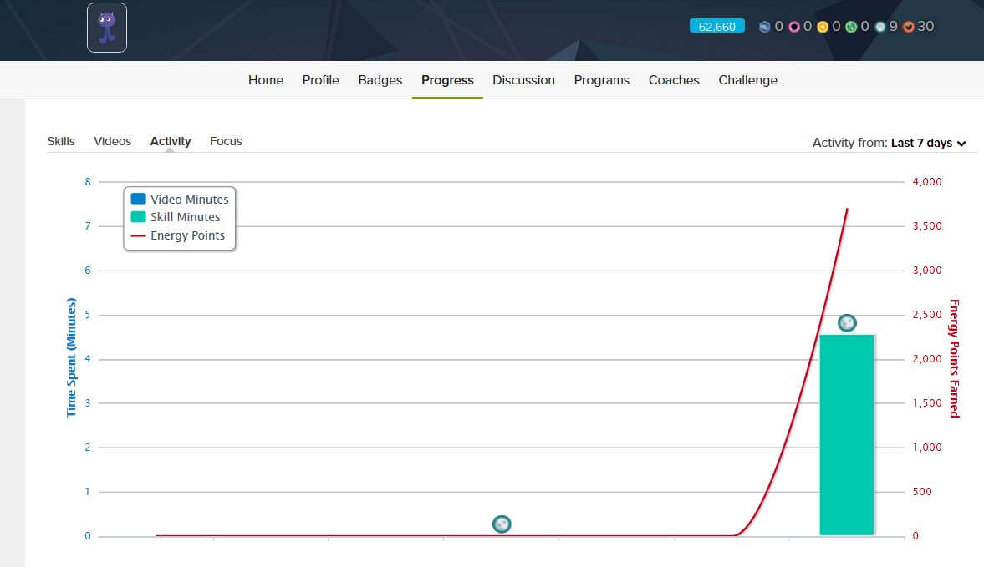
- Confirm I am your coach:
  - Go to your KhanAcademy Profile page
  - Click on Coaches in the right hand column
  - Take a screenshot showing me listed as your coach

