5.5 Roots and Zeros ⸱ Form A
All work must be completed in a clear and organized manner on a separate sheet of paper. Final answers only, boxed in on this sheet.
Example 1
Solve each equation. State the number and type of roots.
1. $x^{2}$ – 4x + 40 = 0 2. $x^{4}$ – 625 = 0

3. $x^{5}$ – 81x = 0 4. 4x² + 1 = 0

5. 2x² – 5x + 14 = 0 6. 8x³ – 27 = 0

7. x³ – 6x² + 7x = 0 8. x⁵ + 2x³ + x = 0

Example 2
State the possible number of positive real zeros, negative real zeros, and imaginary zeros of
each function.
9. h(x) = 4$x^{3}$ – 12$x^{2}$ – x + 3 10. p(x) = $x^{3}$ – $x^{2}$ + 4x – 6

11. f(x) = $x^{4}$ – $x^{3}$ – 5$x^{2}$ + 6x + 1 12. f(x) = 2x³ – 7x² – 2x + 12

13. f(x) = x⁴ – 2x² – 5x + 19 14. f(x) = –x⁵ + 14x³ + 18x – 36

Example 3
Find all of the zeros of each function and use them to sketch a rough graph.
15. g(x) = $x^{3}$ – 6$x^{2}$ + 13x – 10 16. q(x) = $x^{3}$ + 3$x^{2}$ – 6x – 8

17. f(x) = $x^{4}$ – 21$x^{2}$ + 80 18. f(x) = x³ + x² – 17x + 15

19. f(x) = x⁴ + 6x³ + 73x² + 384x + 576 20. f(x) = x⁵ – 8x³ – 9x

Example 4
Write a polynomial that could be represented by each graph.
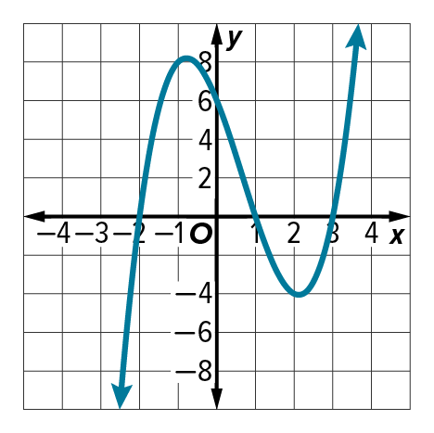
21.

Example 5
22. FISH Some fish jump out of the water. When a fish is out of the water, it’s location is above sea level. When a fish dives back into the water, it’s location is below sea level. A biologist can use polynomial functions to model the location of fish compared to see level. A biologist noticed that a fish is at sea level at –3, –2, –1, 1, 2, and 3 minutes from noon. Graph a polynomial function that could represent the location of the fish compared to sea level y, in centimeters, x seconds from noon.

Mixed Exercises
Write a polynomial function of least degree with integral coefficients that has the given zeros.
23. 5, –2, –1 24. –1, –1, 2i

25. 0, –5, 3 + i

Sketch the graph of each function using its zeros.
26. f(x) = x³ – 5x² – 2x + 24 27. f(x) = x⁴ – 6x³ + 7x² + 6x – 8
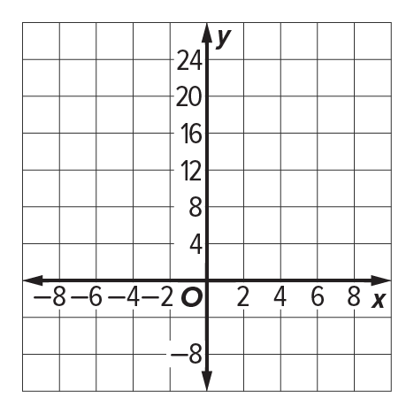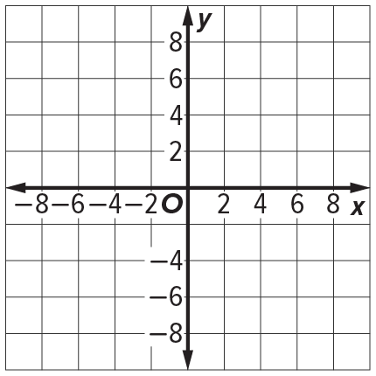

28. USE A SOURCE Linear algebra is the study of linear equations. In linear algebra, the coefficients of linear equations are often organized into rectangular arrays called matrices. Research the eigenvalues of a matrix and how they relate to the roots of a polynomial function. What fields use linear algebra, matrices, and eigenvalues?.

29. ANALYZE Use the zeros to draw the graph of P(x) = x³ – 7x² + 7x + 15 by hand. Discuss the accuracy of your graph, and what could be done to improve the accuracy.

30. CREATE Sketch the graph of a polynomial function with:
a. 3 real, 2 imaginary zeros b. 4 real zeros c. 2 imaginary zeros

31. WHICH ONE DOESN’T BELONG? Determine which equation is not like the others. Justify your conclusion.

32. WRITE Explain to a friend how you would use Descartes’ Rule of Signs to determine the number of possible positive real roots and the number of possible negative real roots of the polynomial function f(x) = x⁴ – 2x³ + 6x² + 5x – 12.

