4.4 Dividing Polynomials ⸱ Form A (All work on separate sheet of paper. Final answers on this WS for full credit.)

Examples 1
Simplify each expression.
1. ${(4f^{5}-6f^{4}+12f^{3}-8f^{2})(4f^{2})}^{–1}$ 2. (4$a^{2}h^{2}$– 8$a^{3}$h + 3$a^{4}$) ÷ (2$a^{2}$)

Examples 2 and 4
Simplify by using long division.
3. (d² + 4d + 3)(d + 1) ^{–1} 4. (6y² + y – 2)(2y – 1)^{–1} 5. (2x² – 5x – 4) ÷ (x – 3)

Examples 4 and 5
Simplify using synthetic division.
6. (3$t^{4}$ + 4$t^{3}$– 32$t^{2}$– 5t – 20)(t + 4)^{–1} 7. $\frac{2x^{3}- x^{2}- 18x+ 32 }{2x – 6}$ 8. (3c⁴ + 6c³ – 2c + 4)(c + 2)^{–1}

Mixed Exercises
Simplify.
9. (a³ – 6a² + 10a – 3) ÷ (a – 3) 10. (x³ + 2x² – 34x + 9) ÷ (x + 7)

11. (6x³ + x² + x) ÷ (2x + 1) 12. (x⁴ – y⁴) ÷ (x – y)

13. (a³b² – a²b + 2b)(-ab)⁻¹ 14. $\frac{p^{3} + 2p^{2} - 7p - 21}{p + 3}$

15. AVERAGES Bena has a list of n + 1 numbers and she needs to find their average. Two of the numbers are n³ and 2. Each of the other n – 1 numbers are all equal to 1. Find the average of these numbers.

16. REASONING Rewrite $\frac{6x^{4} - 2x^{3} - 16x^{2} + 24x + 2}{2x + 4}$ as q(x) + $\frac{r(x)}{d(x)}$ using long division. What does the remainder indicate in this problem?

17. REGULARITY Rewrite $\frac{x^{5} + 2x^{2} + x - 2}{2x + 3}$ as q(x) + $\frac{r(x)}{d(x)}$ using long division.
a. Identify q(x), r(x), and g(x).
b. How can you check your work using the expressions of q(x), g(x), and r(x)?

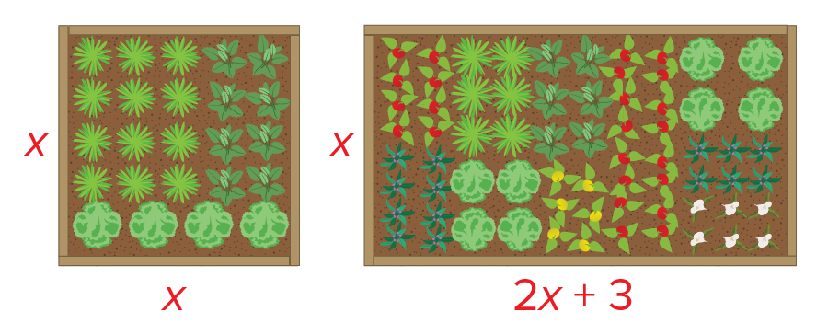
18. USE A MODEL Luciano has a square garden. A new
garden will have the same width and a length that is
3 feet more than twice the width of the original
garden.
a. Define a variable and label each side of the diagrams with an expression for its length.
b. Write a ratio to represent the percent increase in the area of the garden. Use polynomial division to simplify the expression.
c. Use your expression from part b to determine the percent of increase in area if the original garden was a 12-foot square. Check your answer.

19. PERSEVERE If a polynomial is divided by a binomial and the remainder is 0, what does this tell you about the relationship between the binomial and the polynomial?

20. CREATE Write a quotient of two polynomials for which the remainder is 3.

21. PERSEVERE Mr. Collins has his class working with bases and polynomials. He wrote on the board that the number 1111 in base B has the value B³ + B² + B + 1. The class was then given the following questions to answer.
a. The number 11 in base B has the value B + 1. What is 1111 (in base B) divided by
11 (in base B)?
b. The number 111 in base B has the value B² + B + 1. What is 1111 (in base B) divided by
111 (in base B)?

