4.3 Operations with Polynomials ⸱ Form A (All work on separate sheet of paper. Final answers on this WS for full credit.)
Example 1
Determine whether each expression is a polynomial. If it is a polynomial, state the degree of
the polynomial.
1. a³ – 11 2. $\sqrt{m-7}$

Examples 2 and 3
Add or subtract.
3. (7b² + 6b – 7) – (4b² – 2) 4. (5d + 5) – (d + 1)

5. (–2f² – 3f – 5) + (–2f² – 3f + 8) 6. (x² + 2x – 5) – (3x² – 4x + 7)

Examples 4, 5, and 6
Multiply.
7. 4x(2x² + y) 8. x²(2x + 9)

9. (2x – 3)(3x – 5) 10. (a + b)(a³ – 3ab – b²)

11. (a + b)(2a + 3b)(2x – y) 12. (3y + 4)(2y – 3)

13. (4$x^{5}$ + $x^{3}$ – 7$x^{2}$ + 2)(3x – 1)

Example 7
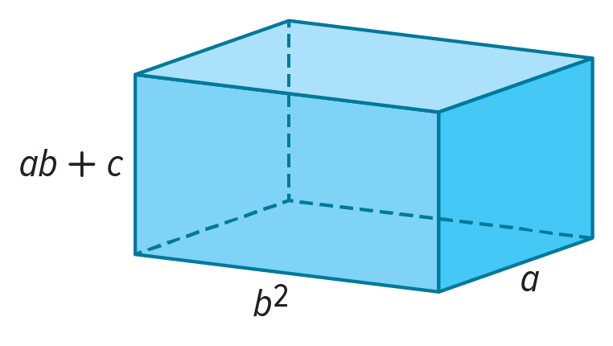
14. VOLUME The volume of a rectangular prism is given by the product of its length, width, and height. A rectangular prism has a length of b² units, a width of a units, and a height of ab + c units. What is the volume of the rectangular prism? Express your answer in simplified form.

Mixed Exercises
Simplify.
15. 5xy(2x – y) + 6y²(x² + 6) 16. $\frac{1}{4}$g²(8g + 12h – 16gh²)

17. (g³ – h)(g³ + h) 18. (2x – 2y)³

19. (3z – 2)³

20. STRUCTURE Use the polynomials f(x) = –6x³ + 2x² + 4 and g(x) = x⁴ – 6x³ – 2x to evaluate
and simplify the given expression. Determine the degree of the resulting polynomial.
Show your work.
a. f(x) + g(x) b. g(x) – f(x)

21. USE A MODEL Inez wants to increase the size of her rectangular garden. The original garden is 8 feet longer than it is wide. For the new garden, she will increase the length by 25% and increase the width by 5 feet.
a. Draw and label a diagram that represents the original garden and the new garden. Define a variable and label each dimension with appropriate expressions.
b. Write and simplify an expression for the increase in area of the garden. If the original width of the garden was 10 feet, find how many square feet the garden’s area increased.

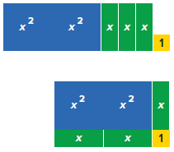
22. STRUCTURE The polynomial 2x² + 3x + 1 can be represented by the tiles shown in the figure at the right. These tiles can be arranged to form the rectangle shown. Notice that the area of the rectangle is 2x² + 3x + 1 units².
a. Find the length and width of the rectangle.
b. Explain how to find the perimeter of the rectangle. Then explain your process for finding the perimeter.
c. Select a value for x and substitute that value into each of the expressions above. For your value of x, state the length, width, perimeter, and area of the rectangle. Discuss any restrictions on the value of x.

23. GEOMETRY Consider a trapezoid that has one base that measures five feet greater than its height. The other base is one foot less than twice its height. Let x represent the height.
a. Write an expression for the area of the trapezoid.
b. Write an expression for the area of the trapezoid if its height is increased by 4 feet.

24. PERSEVERE Use your result from Exercise 48 to make conjectures about the product of a polynomial with m terms and a polynomial with n terms. Justify your conjecture.
a. How many times are two terms multiplied?
b. What is the least number of terms in the simplified product?

25. CREATE Write an expression where two binomials are multiplied and have a product of 9 – 4b².

