3.6 Using the Quadratic Formula and the Discriminant ⸱ Form A
All work must be completed, clearly, on a separate page. Circle/Box final answers only on WS. No work = No credit.

Example 1
Solve each equation by using the Quadratic Formula.
1. x² – 18x + 72 = 0 2. 4x² – 6x = –2 3. –8x² + 4x = –5

Example 2 and 3
Solve each equation by using the Quadratic Formula.
4. x² + 2x – 35 = 0 5. 2x² – x – 15 = 0

6. x² + x – 8 = 0 7. x² – x – 5 = –9

8. x² – 6x + 21 = 0 9. 3x² + 36 = 0

10. 2x² + 2x + 3 = 0 11. 4x² + 2x + 9 = 0

Examples 4 and 5
Find the value of the discriminant for each quadratic equation. Then describe the number and type of roots for the equation.
12. x² – 8x + 16 = 0 13. 3x² – 2x = 0

14. 5x² – 6 = 0 15. x² + 8x + 13 = 0

16. x² – 2x – 17 = 0 17. x² – x + 1 = 0

Mixed Exercises
REGULARITY Describe the discriminant of the related equation used for each graph. Then determine the type and number of roots.
18. 19.
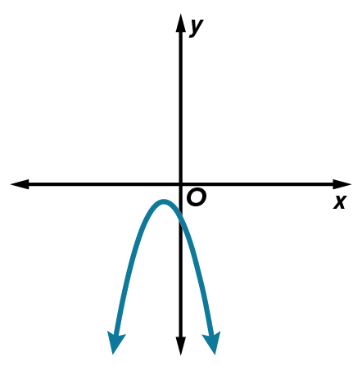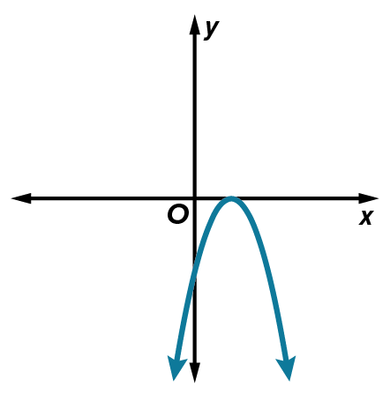

Use the discriminant to describe the number and type of roots for each equation. Then solve each
equation by using the Quadratic Formula.

20. 8x ‒ 1 = 4x² 21. x² + 10x + 24 = 0

22. 12x² + 9x + 1 = 0 23. r² – $\frac{3r}{5}$ + $\frac{2}{25}$ = 0

24. USE A MODEL The height h(t) in feet of an object t seconds after it is propelled up from the with an initial velocity of 60 feet per second is modeled by the equation h(t) = –16t² + 60t. At what times will the object be at a height of 56 feet?

25. STOPPING DISTANCE A car’s stopping distance d is the sum of the distance traveled during the time it takes the driver to react and the distance traveled while braking. This is represented as $d=vt+\frac{v^{2}}{2μg}$, where v is the initial velocity in feet per second, t is the driver’s reaction time in seconds, μ is the coefficient of friction, and g is acceleration due to gravity. Use g = 32 ft/s².
a. Assume μ = 0.8 for rubber tires on dry pavement and the average reaction time of 1.5 seconds to complete the table. Round to the nearest tenth.
b. Make different assumptions to complete the table. Round to the nearest tenth.
coefficient of friction μ = ________________________________________________
reaction time t = ______________________________________________________
c. How did your different assumptions affect the data you found? Interpret the information in the context of the situation.

26. GAMES A carnival game has players hit a pad with a large rubber mallet. This fires a ball up a 20-foot vertical chute toward a target at the top. A prize is awarded if the ball hits the target. Explain how to find the initial velocities in feet per second for which the ball will fail to hit the target. Assume the height of the ball can be modeled by the function h(t) = –16t² + vt, where v is the initial velocity.

27. WHICH ONE DOESN’T BELONG? Use the discriminant to determine which of these equations is different from the others. Explain your reasoning.

28. ANALYZE Determine whether each statement is sometimes, always, or never true. Explain
your reasoning.
a. In a quadratic equation written in standard form, if a and c have different signs, then the solutions will be real.

b. If the discriminant of a quadratic equation is greater than 1, the two roots are real irrational numbers.

29. PERSEVERE Find the value(s) of m in the quadratic equation x² + x + m + 1 = 0 such that it has one solution.

