3.5 Solving Quadratic Equations by Completing the Square ⸱ Form A
All work must be completed, clearly, on a separate page. Circle/Box final answers only on WS. No work = No credit.

Exampled 1-3
Solve each equation by using the Square Root Property.
1. x² + 20x + 100 = 64 2. 4x² + 4x + 1 = 16 3. 16x² + 24x + 9 = 81

4. 25x² + 40x + 16 = 28 5. 36x² + 48x + 16 = 12 6. 4x² – 20x + 25 = 32

7. 2x² –24x + 72 = –162 8. x² – 8x + 16 = –36 9. 3x² – 24x + 48 = –363

Example 4
Find the value of c that makes each trinomial a perfect square. Then write the trinomial as a perfect square trinomial.
10. x² – 14x + c 11. x² + 5x + c 12. x² – x + c

Example 5 and 6
Solve each equation by completing the square.
13. x² + x – 6 = 0 14. x² + 3x – 6 = 0 15. x² – 8x – 65 = 0

Example 7 and 8
Solve each equation by completing the square.
16. 2x² – 8x – 24 = 0 17. 2x² – 13x – 7 = 0 18. 2x² + 7x – 4 = 0

19. x² – 4x + 12 = 0 20. 2x² + 5x + 7 = 0 21. x² = –24

Examples 9 and 10
Write each function in vertex form. Find the axis of symmetry. Then find the vertex, and determine if it is a maximum or minimum.
22. y = x² + 2x – 5 23. y = –x² + 4x + 2 24. y = 2x² + 4x + 3

Example 11
25. FIREWORKS The height of a firework at an amusement park celebration can be modeled by a quadratic function. Suppose the firework is launched 2 feet off the ground at a velocity of 96 feet per second. Hint: Use $h\left(t\right)=-\frac{1}{2}gt^{2}+vt+h_{0}$, where g = 32 $\frac{ft}{s^{2}}$.

a. Write a function to represent this situation.
b. Rewrite the function in vertex form.
c. Find the axis of symmetry and the vertex and interpret their meaning in the context of the situation.

Mixed Exercises
PRECISION Solve each equation. Round to the nearest hundredth, if necessary.

26. 4x² ‒ 28x + 49 = 5
29. x² ‒ 1.8x + 11.24 = 1.43
27. x² + x + $\frac{1}{3}$ = $\frac{2}{3}$
30. 1.1x² ‒ 8.8x + 22 = 2.2
28. x² + 0.7x + 4.1225 = 0

31. REACTION TIME Tela was eating lunch when she saw her friend Jori approach. The room was crowded and Jori had to lift his tray to avoid obstacles. Suddenly, a glass on Jori's lunch tray tipped and fell off the tray. Tela lunged forward and managed to catch the glass just before it hit the ground. The height h, in feet, of the glass t seconds after it was dropped is given by
h = –16t² + 4.5. If Tela caught the glass when it was six inches off the ground, how long was the glass in the air before she caught it?

32. INVESTMENTS Niyati invested $1000 in a savings account with interest compounded annually. After two years the balance in the account is $1210. Use the compound interest formula
A = P(1 + r)^{t} to find the annual interest rate, to the nearest percent.

Write each function in vertex form. Then find the vertex.
33. y = x² + 16x + 65 34. y = x² – 8x + 17

35. DECK DESIGN The Rayburns current deck is 12 feet by 12 feet. They decide they would like to expand their deck and maintain its square shape. How much larger will each side need to be for the deck to have an area of 200 square feet?

36. FIND THE ERROR Alonso and Aika are solving x² + 8x – 20 = 0 by completing the square. Is either of them correct? Explain your reasoning.

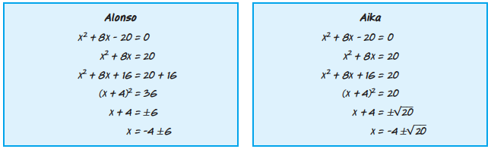

37. ANALYZE Without solving, determine how many unique solutions there are for each equation. Are they rational, real, or complex? Justify your reasoning.
a. (x + 2)² = 16 b. (x ‒ 2)² = 16 c. ‒(x ‒ 2)² = 16

d. 36 ‒ (x ‒ 2)² = 16 e. 16(x + 2)² = 0 f. (x + 4)² = (x + 6)²

38. WRITE Explain what is means to complete the square. Describe each step.

