3.4 Solve Quadratic Equations by Factoring ⸱ Form B
All work must be completed, clearly, on a separate page. Circle/Box final answers only on WS. No work = No credit.

Examples 1 and 2
Solve each equation by factoring. Check your solution.
1. 6x² – 2x = 0 2. 20x² = –25x 3. x² + 14x + 33 = 0

Example 3
4. GEOMETRY The length of a rectangle is 2 feet more than its width. Find the dimensions of the rectangle if its area is 63 square feet.

Example 4
Solve each equation by factoring. Check your solution.
5. 2x² – x – 3 = 0 6. 5x² + 28x – 12 = 0 7. 2x² – 11x – 40 = 0

Example 5–7
Solve each equation by factoring. Check your solution.
8. x² = 64 9. 289 = x² 10. x² – 169 = 0

11. 4x² ‒ 28x + 49 = 0 12. 16x² ‒ 24x + 13 = 4 13. 25x² + 80x + 64 = 0

14. x² + 12 = –13 15. x² = ‒225 16. 36x² = –25

Mixed Exercises
17. FIND THE ERROR Jade and Mateo are solving ‒12x² + 5x + 2 = 0. Is either of them correct? Explain your reasoning.
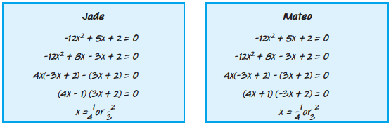

18. CREATE Choose two integers. Then write an equation in standard form with those roots. How would the equation change if the signs of the two roots were switched?

19. WRITE Explain how to factor a trinomial in standard form with a > 1.

