3.4 - Solve Quadratic Equations by Factoring ⸱ Form A
All work must be completed, clearly, on a separate page. Circle/Box final answers only on WS. No work = No credit.

Examples 1 and 2
Solve each equation by factoring. Check your solution.
1. x² = 7x 2. x² + x – 30 = 0 3. x² – 3x = 10

Example 3
4. PHOTOGRAPHY The length and width of a 6-inch by 8-inch photograph are reduced by the same amount to make a new photograph with area that is half that of the original. By how many inches will the dimensions of the photograph have to be reduced?

Example 4
Solve each equation by factoring. Check your solution.
5. 6x² – 5x – 4 = 0 6. 12x² – 8x + 1 = 0 7. 3x² + 2x = 21

Example 5–7
Solve each equation by factoring. Check your solution.
8. x² – 100 = 0 9. x² + 14 = 50 10. 124 = x² + 3

11. 9x² + 6x = ‒1 12. 81x² + 36x = ‒4 13. 9x² + 60x + 95 = ‒5

14. x² + 100 = 0 15. x² + 4 = 0 16. 64x² = –49

Mixed Exercises
STRUCTURE Solve each equation by factoring. Check your solution.
17. 27x² + 5 = 48x 18. 45x² ‒ 3x = 2x 19. 16x² + 8x = ‒1

20. ANIMATION A computer graphics animator would like to make a realistic simulation of a tossed ball. The animator wants the ball to follow the parabolic trajectory represented by
f(x) = –0.2(x + 5)(x – 5).
a. What are the solutions of f(x) = 0?
b. If the animator changes the equation to f(x) = –0.2x² + 20, what are the solutions of f(x) = 0?

21. Find two consecutive odd positive integers whose product is 323.

22. FIND THE ERROR Jade and Mateo are solving ‒12x² + 5x + 2 = 0. Is either of them correct? Explain your reasoning.
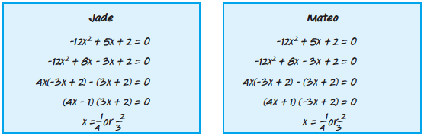

23. PERSEVERE The rule for factoring a difference of cubes is shown below. Use this rule to factor
40x⁵ ‒ 135x²y³.
a³ ‒ b³ = (a ‒ b)(a² + ab + b²)

24. CREATE Choose two integers. Then write an equation in standard form with those roots. How would the equation change if the signs of the two roots were switched?

25. ANALYZE Determine whether the following statement is sometimes, always, or never true. Explain your reasoning.
In a quadratic equation in standard form where a, b, and c are integers,
If b is odd, then the quadratic cannot be a perfect square trinomial.

__________, _______________________________________________________________________________________

26. WRITE Explain how to factor a trinomial in standard form with a > 1.

__________________________________________________________________________________________________

__________________________________________________________________________________________________

__________________________________________________________________________________________________

