2.7 - Optimization with Linear Programming ⸱ Form A

Example 1
Graph the system of inequalities. Name the coordinates of the vertices of the feasible region. Find the maximum and minimum values of the function for this region. Use the attached graph paper.
1. y ≥ 2 2. y ≥ –2 3. x + y ≥ 2
1 ≤ x ≤ 5 y ≥ 2x – 4 4y ≤ x + 8
y ≤ x + 3 x – 2y ≥ –1 y ≥ 2x – 5
f(x, y) = 3x – 2y f(x, y) = 4x – y f(x, y) = 4x + 3y

4. x ≥ 2 5. x ≥ 1 6. x ≥ 0
x ≤ 5 y ≤ 6 y ≥ 0
y ≥ 1 y ≥ x ‒ 2 y ≤ 7 ‒ x
y ≤ 4 f(x, y) = x ‒ y f(x, y) = 3x + y
f(x, y) = x + y

Example 2
Graph the system of inequalities. Name the coordinates of the vertices of the feasible region. Find the maximum and minimum values of the function for this region. Use the attached graph paper.
7. x ≥ –1 8. y ≤ 2x 9. y ≤ 3x + 6
x + y ≤ 6 y ≥ 6 ‒ x 4y + 3x ≤ 3
f(x, y) = x + 2y y ≤ 6 x ≥ ‒2 f(x, y) = 4x + 3y f(x, y) = ‒x + 3y

Example 3
10. PAINTING A painter has exactly 32 units of yellow dye and 54 units of green dye. He plans to mix as many gallons as possible of color A and color B. Each gallon of color A requires 4 units of yellow dye and 1 unit of green dye. Each gallon of color B requires 1 unit of yellow dye and 6 units of green dye. Find the maximum number of gallons he can mix.
a. Define the variables and write a system of inequalities.
b. Graph the system of inequalities and find the coordinates of the vertices of the feasible region.
c. Find the maximum number of gallons that he can make.

11. REASONING A Jewelry company makes and sells necklaces. For one type of necklace,
the company uses clay beads and glass beads. Each necklace has no more than
10 clay beads and at least 4 glass beads. For every necklace, four times the number
of glass beads is less than or equal to 8 more than twice the number of clay beads.
Each clay bead costs $0.20 and each glass bead costs $0.40. The company wants
to find the minimum cost to make a necklace with clay and glass beads and find the
combination of clay and glass beads in a necklace that costs the least to make.
a. Define the variables and write a system of inequalities. Then write an equation for the cost C.
b. Graph the system of inequalities and find the coordinates of the vertices of the feasible region.
c. Find the number of clay beads and glass beads in a necklace that costs the least to make.

Mixed Exercises
12. REASONING Juan has 8 days to make pots and plates to sell at a local fair. Each pot weighs 2 pounds and each plate weighs 1 pound. Juan cannot carry more than 50 pounds to the fair. Each day, he can make at most 5 plates and 3 pots. He will make $12 profit for every plate and $25 profit for every pot that he sells.
a. Write linear inequalities to represent the number of pots p and plates a Juan may bring to the fair.
b. List the coordinates of the vertices of the feasible region.
c. How many pots and how many plates should Juan make to maximize his potential profit?

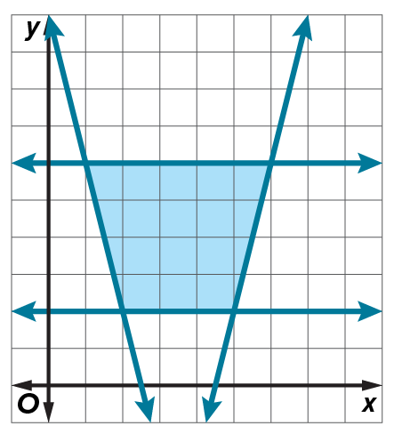
13. USE A MODEL A trapezoidal park is built on a slight incline. The ground elevation above sea level is given by f(x, y) = x – 3y + 20 feet. What are the coordinates of the highest point in the park and what is the elevation at that point?

14. FOOD A zoo is mixing two types of food for the animals. Each serving is required to have at least 60 grams of protein and 30 grams of fat. Custom Foods has 15 grams of protein and 10 grams of fat and costs 80 cents per unit. Zookeeper’s Best contains 20 grams of protein and 5 grams of fat and costs 50 cents per unit.
a. The zoo wants to minimize their costs. Define the variables and write the inequalities that represent the constraints of the situation.
b. Graph the inequalities. What does the unbound region represent? Determine
how much of each type of food should be used to minimize costs.

15. ANALYZE Determine whether the following statement is sometimes, always, or never true. Explain your reasoning.
An unbounded region will not have both a maximum and minimum value.

16. WRITE Upon determining a bounded feasible region, Kelvin noticed that vertices A(–3, 4) and B(5, 2) yielded the same maximum value for f(x, y) = 16y + 4x. Kelvin confirmed that his constraints were graphed correctly and his vertices were correct. Then he said that those two points were not the only maximum values in the feasible region. Explain how this could have happened.

