2.6 - Solving Systems of Inequalities ⸱ Form A

Example 1
Solve each system of inequalities. Use the attached graph paper.
1. 3x – 2y ≤ –1 2. y < $\frac{x}{3}$ + 2 3. x + 3y < 3
x + 4y ≥ –12 y < –2x + 1 x – 2y ≥ 4

Example 2
Solve each system of inequalities. Use the attached graph paper.
4. x > ‒3 5. y ≤ 0 6. x ≥ ‒2
y < – $\frac{1}{3}$x + 3 x ≤ 0 y ≥ x ‒ 2 y > x – 1 y ≥ ‒x ‒ 1 x + y ≤ 2

Example 3
7. CONSTRUCT ARGUMENTS Anthony charges $15 an hour for tutoring and $10 an hour for babysitting. He can work no more than 14 hours a week. How many hours should Anthony spend on each job if he wants to earn at least $125 each week?

a. Write a system of inequalities to represent this situation.
b. Graph the system of inequalities and highlight the solution.
c. Determine whether (4, 5), (7, 6), and (5, 10) are viable solutions given the constraints of the situation. Explain.

Mixed Exercises
Solve each system of inequalities. Use the attached graph paper.
8. y ≥ |2x + 4| ‒ 2 9. y ≥ |6 ‒ x|
3y + x ≤ 15 |y| ≤ 4

10. y > ‒3x + 1 11. x > y
4y ≤ x ‒ 8 y ≤ 6
3x ‒ 5y < 20 y ≥ ‒2

12. FINANCE Sheila plans to invest $2000 or less in two different accounts. The low risk account pays 3% annual simple interest, and the high risk account pays 12% annual simple interest. Sheila wants to make at least $150 in interest this year.
a. Define the variables, then write and graph a system of inequalities to show how Shiela can split her investment between the accounts.

b. Explain why your graph for this situation is restricted to Quadrant I.

c. Give three viable solutions to meet the constraints of Sheila’s investments.

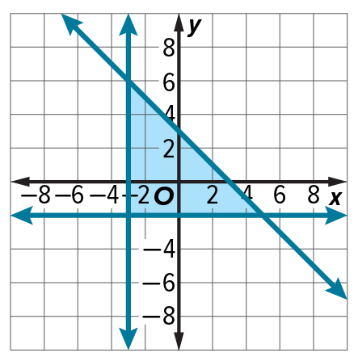
13. STRUCTURE Write a system of inequalities for the graph shown.

14. PERSEVERE Find the area of the region defined by the following inequalities. Use the attached graph paper.
y ≥ ‒4x ‒ 16
4y ≤ 26 ‒ x
3y + 6x ≤ 30
4y ‒ 2x ≥ ‒10

15. ANALYZE Determine whether the statement is true or false. Justify your argument. A system of two linear
inequalities has either no points or infinitely many points in its solution.

