2.4 - Solving Systems of Equations Graphically ⸱ Form A

Example 1
Determine the number of solutions for each system. Then state whether the system of equations is consistent or inconsistent and whether it is independent or dependent.
1. y = x ‒ 5 2. 3x + y = –2 3. 3x – y = 2
–2x + 2y = –10 6x + 2y = 10 x + y = 6 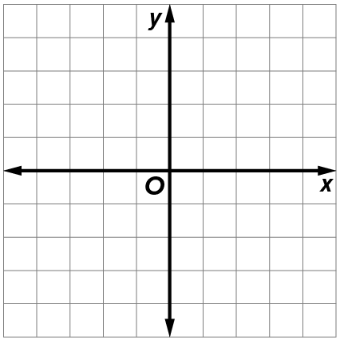

Examples 2 and 3
Solve the system of equations by graphing.
4. –4x + 6y = –2 5. y – x = 3 6. 5x – y = 4
2x – 3y = 1 y = 1 –2x + 6y = 4

Example 4
Solve each problem.
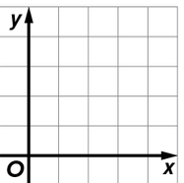
7. USE ESTIMATION Two moving truck companies offer the same vehicle at different rates. At Haul-n-Save, the truck can be rented for $30, plus $0.79 per mile. At Rent It Trucks, the truck can be rented for $75, plus $0.55 per mile.
a. Write equations for the total cost of renting a truck from each company.
b. Graph the equations on the same coordinate plane. Examine the graph to estimate after how many miles of driving the total rental cost will be the same from each company.
c. Check your estimate. How reasonable is your estimation? Justify your reasoning.

Example 5 and 6
USE TOOLS Use a graphing calculator to solve each system of equations. Round the coordinates to the nearest hundredth, if necessary.
8. ‒3.8x + 2.9y = 19
6.6x ‒ 5.4y = ‒23

Example 6
USE TOOLS Use a graphing calculator to solve each system of equations. Round the coordinates to the nearest hundredth, if necessary.
9. ‒4.7x + 16 = 16.79x ‒ 80.2 10. 471 ‒ 63x = ‒50.5x + 509
Mixed Exercises
Solve each system of equations by graphing.
11. x ‒ 3y = 6 12. 4x + y = ‒2
2x ‒ y = ‒3 2x + $\frac{y}{2}$ = ‒1
13. REASONING A high school band was selling ride tickets for the school fair. On the first day, 250 children’s tickets and 150 adult tickets were sold for a total of $550. On the second day, 180 children’s tickets and 120 adult tickets were sold for a total of $420. What is the price for each child ticket and each adult ticket?
a. Write a system of equations to represent this situation.

b. Graph the system of equations.

c. Find the intersection of the graphs. What does the point of intersection represent?

14. ANALYZE If a is consistent and dependent with b, b is inconsistent with c, and c is consistent and independent with d, then a will sometimes, always, or never be consistent and independent with d. Explain your reasoning.

15. ANALYZE Determine if the following statement is sometimes, always, or never true. Explain your reasoning.
A system of linear equations in two variables can have exactly two solutions.

