Equations of Linear Functions ⸱ Form A
Example 1
Write each equation in standard from. Identify A, B, and C.
1. 8x + 3y + 6 = 0 2. $\frac{2}{3}y-\frac{3}{4}x+\frac{1}{6}=0$ 3. ‒0.08x = 1.24y ‒ 3.12

Example 2
Write each equation in slope-intercept form. Identify the slope m and the y-intercept b.
4. 14x ‒ 7y = 21 5. 5x + 10y = 20 6. $\frac{1}{5}x+\frac{1}{2}y=4$

Example 3
7. GROWTH Suppose the body length y in inches of a baby snake is given by 4x ‒ 2y = ‒3, where x is the age of the snake in months until it becomes 1 year old. Write the equation in slope-intercept form and interpret the parameters of the equation in the context of the situation.

Example 4
8. HIKING Tim began a mountain hike near Big Bear Lake, California at 9:00 a.m. By 10:30 a.m., his elevation is 7200 feet above sea level. At 11:15 p.m., he is at an elevation of 7425 feet above sea level.
a. Define variables to represent the situation.
b. Write an equation in slope-intercept form that represent Tim’s elevation since he began hiking.
c. If Tim’s altitude continues to increase at the same rate, estimate his altitude at 12:30 p.m.

Example 5
Write an equation in point-slope form for the line that satisfies each set of conditions.
9. slope of $\frac{4}{5}$, passes through (10, ‒3) 10. slope of 0, passes through (0, ‒10)

Example 6
Write an equation in point-slope form for a line that passes through each set of points.
11. (3, 5) and (‒6, ‒4) 12. (‒2, ‒4) and (1, 8)

Example 7
Solve each problem.
13. RESTAURANTS In 2012, a popular pizza franchise had 2483 restaurants. In 2017, there were 2606 franchised restaurants. Write an equation in point-slope form that represents the number of restaurants y that are franchised x years after 2010.

Mixed Exercises
REGULARITY Write linear equations in standard form, slope-intercept form, and point-slope form that satisfy each set of conditions.
14. x-intercept: 3, y-intercept: 5 15. slope of 0.6, passes through (1, 1)

16. USE A SOURCE Go online to find the population of your city in 2010 and 2015. Write an equation in slope-intercept form to represent the population y of the city x years after 2010. State assumptions you made to write the equation.

17. USE ESTIMATION In May, Jacalyn opens a savings account with an initial balance of $200 and deposits about the same amount each month. The table shows her account balance at the beginning of each month.

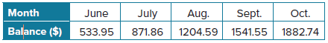
a. Write a linear equation in slope-intercept form that relates the balance of her savings account y in months x since she opened her account.
b. Estimate the balance of Jacalyn’s account at the beginning of December.

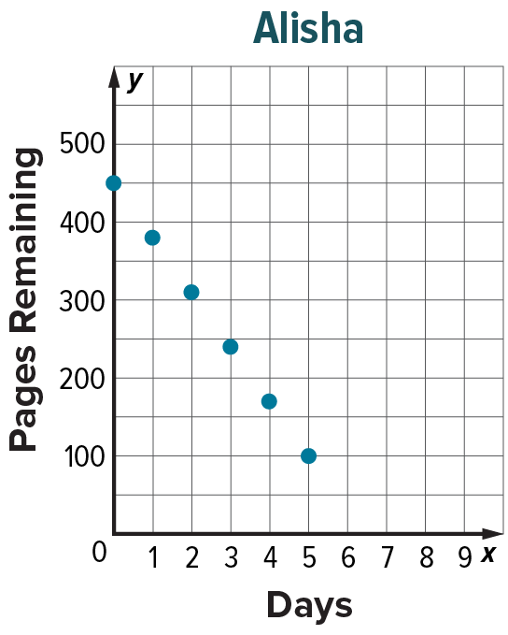
18. USE A MODEL Joe and Alisha are reading novels for book reports. Joe records the number of pages he has remaining to read after each day in the table below. Alisha records the number of pages she has remaining each day on the graph at the right.
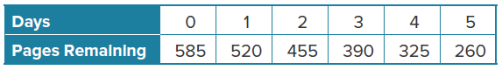
a. Describe the function that models the number of pages remaining for each student.
b. What is the y-intercept for each function? Interpret its meaning in the context of the problem.
c. Write a linear equation in slope-intercept for the function that can be used to model the pages remaining for each student. Then write each equation in standard form.
d. After how many days will each student finish reading their book? What feature of the function represents this event? Explain your answer.
e. Who is the faster reader and by how many pages per day? Support your answer.

19. CONSTRUCT ARGUMENTS Determine whether an equation in the form x = a, where a is a constant is sometimes, always, or never a function. Explain your reasoning.

20. PERSEVERE Write an equation in point-slope form of a line that passes through (a, 0) and (0, b).
21. CREATE Write an equation in point-slope form of a line with an x-intercept of 3.

22. WRITE Consider the relationship between hours worked and earnings. When would this situation represent a linear relationship? When would this situation represent a nonlinear relationship? Explain your reasoning.

23. FIND THE ERROR Dan claims that since y = x + 1 and y = 3x + 2 are both linear functions, the function y = (x + 1)(3x + 2) must also be linear. Is he correct? Explain your reasoning.

24. PERSEVERE Write y = ax + b in point-slope form.

25. WRITE Why is it important to be able to represent linear equations in more than one form?

