Transformations of Functions ⸱ Form A

Example 1
Describe each translation as it relates to the graph of the parent function.
1. y = |x| – 3 2. y = x + 2 3. y = |x + 6|

Example 2
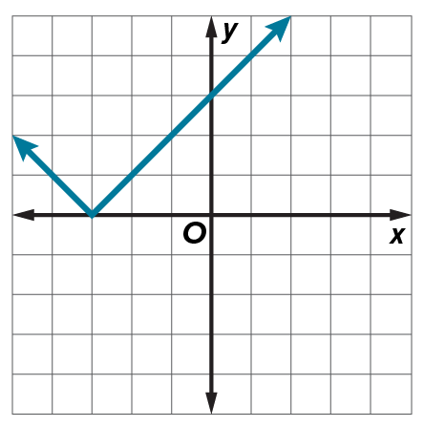
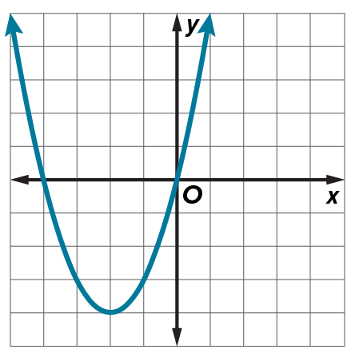
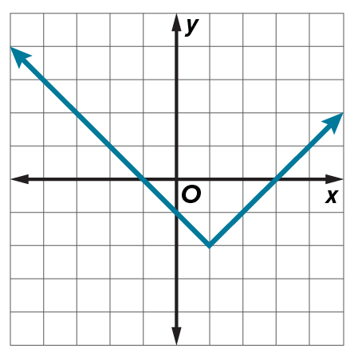
Use the graph of each translated parent function to write its equation.
4. 5. 6.

Examples 3 and 4
Describe each dilation and reflection as it relates to the parent function.
7. y = –6x 8. y = |–2x|

9. y = $-\frac{1}{2}$x² 10. y = ${\left(-\frac{3}{4}x\right)}^{2}$

Example 5
Describe each transformation as it relates to the graph of the parent function.
11. y = 3x + 11 12. y = $\frac{1}{2}$|x – 1| + 14 13. y = (1.5x)² + 22

Example 6
14. SALAD The cost for a salad depends on its weight, x, in ounces, and is described by
c(x) = 4.5 + 0.32x. Describe how c(x) is related to its parent function and interpret the function
in the context of the situation.

15. ARCHERY The path of an arrow can be modeled by h(x) = –0.03x² + 6, where x is distance and h(x) is height, both in feet. Describe how h(x) is related to its parent function and interpret the function in the context of the situation.

Example 7
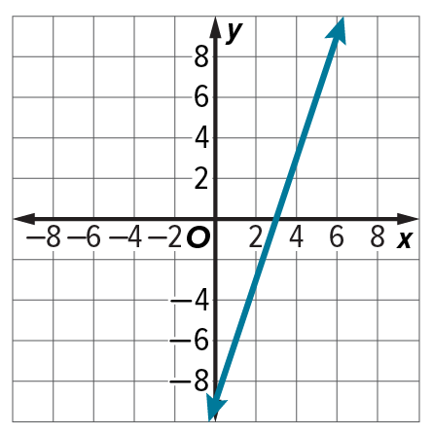
Write an equation for each function.
16.

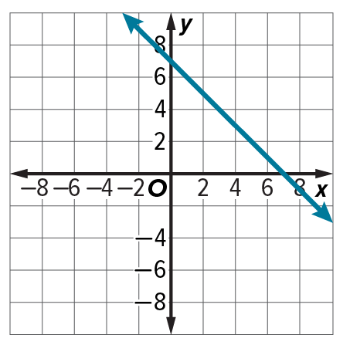
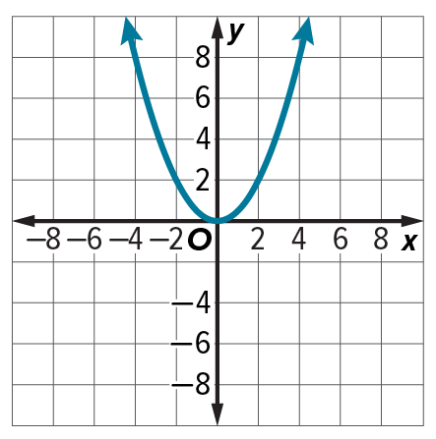
Write an equation for each function.
17. 18.

Mixed Exercises
Describe each transformation as it relates to the graph of the parent function. Then graph
the function.
19. y = ${(x + 1)}^{2}$ 20. y = –|x| 21. y = 2x²

22. Describe the reflection in y = –x³ as it relates to the parent function.

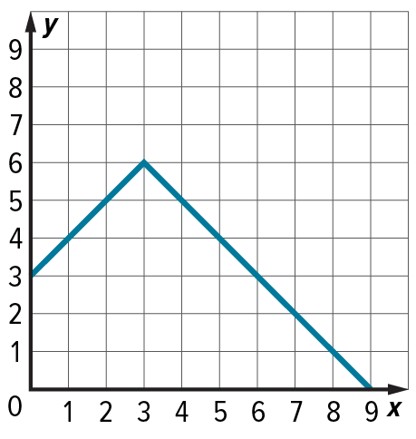
23. ARCHITECTURE The cross-section of a roof is shown in the figure. Write an absolute value function that models the shape of the roof.

24. GRAPHIC DESIGN Kassie sketches the function, f(x) = ‒1.25(x ‒ 1)² + 18.75 as part of a new logo design. Describe the transformations she applied to the parent function in creating her function.

25. REASONING Compare the graph of the parent function f(x) = |x| with the graphs of g(x) = |x + 2| and h(x) = |x – 3|. How are the graphs similar? How are they different?

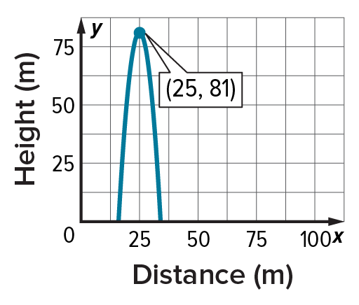
26. PRESEVERE Laura ketches the path of a model rocket that she launches.
a. What type of function does the graph show?
b. In which axis has the function been reflected?
c. How has the graph been translated? Assume that the function has not dilated.
d. What is the equation for the curve shown on the graph?

27. ANALYZE Consider the functions f(x) = |2x|, g(x) = x + 2, h(x) = 2x², and k(x) = 2x³.
a. Graph each function and its reflection in the y-axis.
b. Analyze the functions and the graphs. Determine whether each function is odd, even,
or neither.
c. Recall that if for all values of x, f(–x) = f(x) the function f(x) is an even function. If for all values of x, f(–x) = –f(x) the function f(x) is an odd function. Explain why this is true.

28. CREATE Draw a graph in Quadrant II. Use any of the transformations you learned in this lesson to move your figure to Quadrant IV. Describe your transformation.

29. WRITE Explain why the graph of g(x) = (─x)² appears the same as the graph of f(x) = x². Is this true for all reflections of quadratic functions? If not, describe a case when it is false.

