Sketching Graphs and Comparing Functions ⸱ Form A

Examples 1 and 2
Use the key features of each function to sketch its graph.
1. x-intercept: (0, 0) 2. x-intercept: (5, 0)
y-intercept: (0, 0) y-intercept: (0, 2)
Linearity: linear Linearity: linear
Continuity: continuous Continuity: continuous
Positive: for values x < 0 Positive: for values x < 5
Negative: for values of x > 0 Decreasing: for all values of x
Decreasing: for all values of x End Behavior: As x → ∞, f(x) → −∞ and
End Behavior: As x → ∞, f(x) → −∞ and as x → −∞, f(x) → ∞.
as x → −∞, f(x) → ∞.

3. x-intercept: (–3, 0) and (2, 0) 4. x-intercept: (–2, 0) and (2, 0)
y-intercept: (0, –4) y-intercept: (0, –1)
Linearity: nonlinear Linearity: nonlinear
Continuity: continuous Continuity: continuous
Positive: for values x < −3 and x > 2 Symmetry: symmetric about the line x = 0
Negative: for values of –3 < x < 2 Positive: for values x < −2 and x > 2
Increasing: for all values of x > 0 Negative: for values of –2 < x < 2
Decreasing: for all values of x < 0 Increasing: for all values of x > 0
Extrema: minimum at (0, −4) Decreasing: for all values of x < 0
End Behavior: As x → ∞, f(x) → ∞ and Extrema: minimum at (0, −1)
as x → −∞, f(x) → ∞. End Behavior: As x → -∞, f(x) → ∞and as
x → ∞, f(x) → ∞.

Example 3
5. SCOOTERS Greg rides his motorized scooter for 20 minutes. Greg starts riding at 0 mph. Greg’s maximum speed is 35 mph, which he reaches 5 minutes after he starts riding. Greg’s speed increases steadily for 5 minutes. At the 10-minute mark, Greg decreases his speed for
2.5 minutes, then he stays at 20 mph for 5 minutes. At the 17.5-minute mark, he again decreases his speed for 2.5 minutes until he stops. Use the key features to sketch a graph.

Examples 4 and 5
6. Compare the key features of the functions represented with a graph and a verbal description.

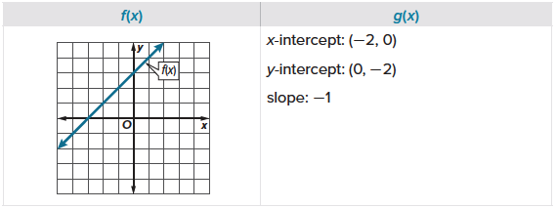

7. Compare the key features of the functions represented with a graph and a verbal description.

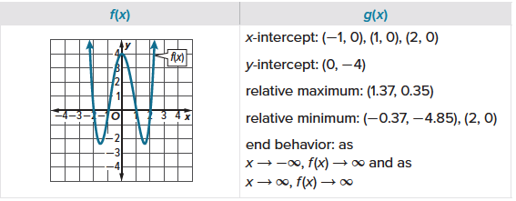
8. Compare the key features of the functions represented with a graph and a table.

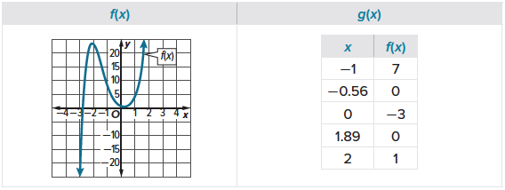
MIXED EXERCISES
9. WATER Sia filled a pitcher with water. The pitcher started with 0 ounces of water. After 8 seconds the pitcher contains 64 ounces of water. The function that models the situation is linear.
a. Use the key features to sketch a graph.
b. What is the end behavior of the graph? Explain.
10. USE A SOURCE Research the value of a new car after it is purchased. Use the information you collect to describe key features of a graph that represents the value of a new car x years after it is purchased. Then use the key features to sketch a graph.

11. CONSTRUCT ARGUMENTS Keisha babysits for her aunt for an hourly rate of $9. The graph shows Keisha’s earnings y as a function of hours spent babysitting x. Explain why the graph only exists for positive x- and y-values.

12. CREATE Choose a function and create a list key features to describe the function. Then sketch the function.

13. ANALYZE Determine whether the statement is always, sometimes, or never true.
A graph that has more than one x-intercept is represented by a nonlinear function.

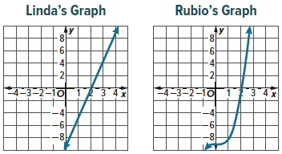
14. FIND THE ERROR Linda and Rubio sketched a graph with the following key features. The x-intercept is 2. The y-intercept is
–9. The function is positive for x > 2. As x → –∞, f(x) → –∞ and as x → ∞, f(x) → ∞. Is either graph correct based on the key features? Explain your reasoning.

